Карточка № 1.
Упражнения на отработку употребления кострукции have got/ has got.
Упражнение № 1 .
Заполни пропуски формой have got or has got.
- I ________ a mouse
- You _________a mouse.
- He_________a mouse.
- He _________ no mouse.
- She_________no mouse.
- It _________ a sheep.
- We _________ a sheep.
- They _________a sheep.

Упражнение № 2.
Запиши нужную форму конструкции have got, has got, haven't got or hasn't got. About you.

- I _________ long fair hair.
- My mum _________ big blue eyes.
- My dad ________ short dark hair.
- I _________a little mouth.
- My brother ______ little ears.
- My friend __________a big nose.
- My granny __________ a small face.
- My teacher __________ short hair.

Карточка № 2.
Упражнение на отработку умения описания животного.
По картинке выполни описание животного. При необходимости воспользуйся словарём.
This animals is_______________________.
It has got a________________________tail.
It has got a_____________________________legs.
It has got a _________________ears.
It is_____________________________________.

Карточка № 3.
Упражнения на отработку употребления Past Simple.
Заполни пропуски правильной формой глагола в скобках.
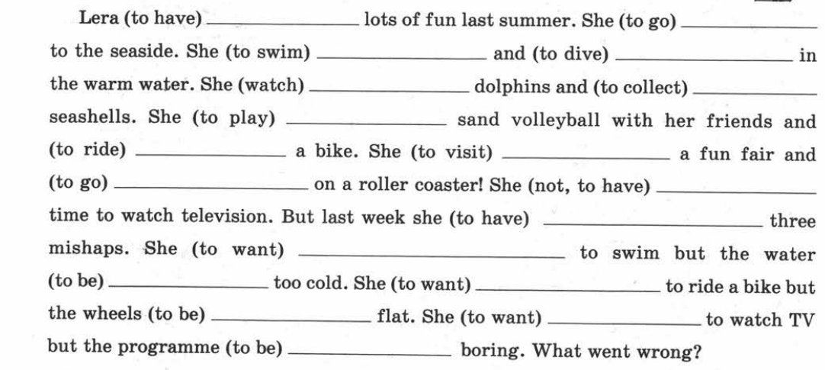
Карточка № 4.
Упражнения на отработку употребления Past Simple и Past Continuous.
Раскройте скобки, употребляя глаголы в Past Simple или Past Continuous.
- I (to go) to the cinema yesterday.____________________________________________
- I (to go) to the cinema at four o’clock yesterday.________________________________
- They (to go) to the cinema when they met me.__________________________________
- She (to learn) words the whole evening yesterday._______________________________
- She (to learn) words when mother came home.__________________________________
- He (to work) in the garden yesterday.__________________________________________
- He (to work) in the garden from five till eight yesterday.__________________________
- My sister is fond of reading. She (to read) the whole evening yesterday.______________
- The children (to do) their lessons at six o’clock yesterday._________________________
- I (not to play) the piano yesterday. I (to write) a letter to my friend.__________________
- I (not to play) the piano at four o’clock yesterday. I (to read) a book._________________
- He (not to sleep) when father came home. He (to do) his homework._________________
- When I (to go) to school the day before yesterday, I met Mike and Pete. They (to talk) and (to eat) an ice-cream.___________________________________________________
- The baby (to sleep) the whole evening yesterday. She (feel) bad.____________________
- What your father (to do) from eight till nine yesterday?___________________________
- Why she (to cry) when I saw her yesterday?____________________________________

Карточка № 5.
Упражнение на отработку употребления альтернативного (присоединительного) вопроса.
Поставите правильный «хвостик» в альтернативном вопросе.
- She doesn’t like watching TV, ______________?
- Her brother is older that she, ________________?
- He doesn’t go to extra classes, _______________?
- You should tell your husband the truth, ________?
- I was a good student, _______________________?
- Dolphins are very kind animals, _______________?
- His performance was boring, _________________?
- She has read a very interesting book, ___________?

Карточка № 6.
Упражнение на отработку умения составлять специальные вопросы.
Поставь слова в правильном порядке чтобы получились специальные вопросы.
Карточка № 7.
Упражнение на отработку употребления модального глагола can.
Заполни пропуски нужной формой глагола can or can’t.

- I _______ draw.
- I _______
- My friends_______ roller-skate.
- My granddad _______sing.
- I_______ ride a bike.
- My mum _______ski.
- My dad _______skate.
- My pet _______play football.

